Dog Breed Identification Using Transfer Learning

1. INTRODUCTION

1.1 Project Overview

Electric Motor Temperature Prediction using Machine Learning is a data-driven system designed to accurately predict the permanent magnet (PM) temperature of an electric motor based on operational parameters such as voltage, current, torque, speed, coolant temperature, and ambient conditions. With the increasing adoption of electric motors in industries and electric vehicles, monitoring motor temperature is critical to ensure safety, efficiency, and reliability.

This project uses a trained machine learning regression model to analyze sensor data and learn patterns that influence motor temperature. Users can enter real-time motor parameters through a web-based interface, and the system predicts the PM temperature instantly. The application is developed using Flask for backend processing and HTML/CSS for the frontend interface, making it simple and interactive for users.

The primary objective of this project is to provide a fast, automated, and reliable solution for predicting motor temperature, helping prevent overheating, improve performance, and reduce equipment failure in industrial and automotive applications.

1.2 Purpose
The purpose of this project is to design and implement a machine learning–based system capable of predicting electric motor temperature accurately using operational sensor data. This system aims to achieve the following objectives:
- Automated Temperature Prediction: Eliminate manual calculations by using a trained ML model
- Accuracy Improvement: Use regression models to achieve reliable temperature estimation
- User-Friendly Interface: Provide a simple web application to enter values and get predictions
- Real-Time Prediction: Enable instant prediction using a deployed ML model
- Practical Applications: Support preventive maintenance in industries and electric vehicles

2. IDEATION PHASE

2.1 Problem Statement
- Electric motor overheating is one of the major causes of equipment failure in industries and electric vehicles. Traditional temperature monitoring methods rely on physical sensors, which may fail, degrade over time, or not be available in all locations of the motor. Manual inspection and rule-based systems are inaccurate and cannot adapt to changing operating conditions.
Challenges:
- Motor temperature varies with load, speed, current, and cooling conditions
- Sensor failure or noise leads to incorrect temperature readings
- Manual monitoring is time-consuming and error-prone
- Unexpected overheating can cause damage and downtime
Challenge Statement:
How can we accurately predict the electric motor temperature using machine learning models in real time based on sensor data, while ensuring reliability, efficiency, and ease of use?

2.2 Empathy Map Canvas
Canvas Element | Description
USER | Maintenance Engineer / EV Technician / Industrial Operator
THINKS | “Can I know the motor temperature before it overheats?”
FEELS | Concerned about equipment damage and safety
SAYS | “I need an easy way to predict motor temperature.”
DOES | Monitors sensor values, checks dashboards, runs diagnostics
PAIN POINTS | Unexpected failures, sensor dependency, downtime
GAINS | Predictive maintenance, safety, reduced failures

2.3 Brainstorming

Ideas Generated:
• Use historical motor sensor dataset for training
• Apply regression-based machine learning models
• Build a web interface for easy user input
• Show predicted temperature with input values
• Save recent predictions
• Visualize results
• Deploy as a Flask web app

Selected Approach:
Develop a regression-based machine learning model trained on electric motor sensor data. Deploy the trained model using a Flask web application that allows users to input operational parameters and receive real-time temperature predictions.

3.REQUIREMENT ANALYSIS

3.1 Customer Journey Map

Stage | User Action | Touchpoints | Pain Points | Emotion
Awareness | Notices motor overheating | Machines, sensors | No prediction system | Concerned
Consideration | Searches for ML solution | Internet, tools | Complex tools | Hopeful
Decision | Chooses ML prediction system | Web app | Accuracy doubts | Confident
Implementation | Enters motor parameters | Input form | Data entry | Slightly Anxious
Usage | Gets temperature output | Result page | Understanding output | Satisfied
Evaluation | Uses result for decisions | Dashboard | Need accuracy | Confident

3.2 Solution Requirements

Functional Requirements:
- • Accept motor sensor values as input
- • Preprocess input values
- • Predict PM temperature using ML model
- • Display predicted temperature
- • Show entered values
- • Load trained model from file
Non-Functional Requirements:
- Web-based interface
- Fast response (< 2 seconds)
- User-friendly design
- Local deployment
- Secure handling of inputs

3.3 Data Flow Diagram

Level 0 (Context Diagram):
User → Web Interface → ML Model → Predicted Temperature
Level 1 (Detailed Flow):
User Input → Flask Server → Data Preprocessing → ML Model → HTML Output
.

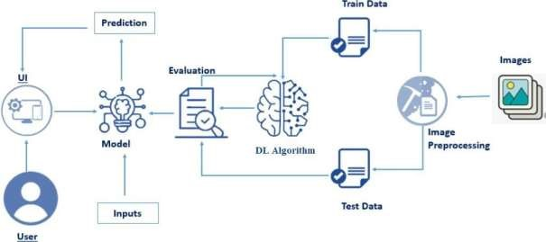

3.4Technology Stack

Component | Technology | Purpose
Programming Language | Python 3.11 | Core application development
Data Processing | Pandas, NumPy | Image preprocessing
Deep Learning | Scikit-learn | CNN model building
Machine Learning model | Scikit-learn | Dog breed classification
Web Framework | Flask | Backend web application
Model Persistence | Flask | Save/load model
Frontend | HTML, CSS | User interface
Development Env. | VS Code, Jupyter Notebook | Model training & app development

4. PROJECT DESIGN

4.1 Problem Solution Fit
Problem | Proposed Solution | Fit Level
Overheating risk | ML temperature prediction | High
Manual monitoring | Automated prediction | High
Sensor failure |  | Medium
  Data-driven model
Downtime | Preventive alerts | High

4.2 Proposed Solution

A machine learning–based web application that:
- Accepts motor parameters
- Predicts PM temperature
- Displays results clearly
- Supports preventive maintenance
- Works in real-time

4.3 Solution Architecture
The architecture consists of four layers:
Layer 1 – UI: Input form & result display
Layer 2 – App Layer: Flask server
Layer 3 – Processing Layer: ML model
Layer 4 – Data Layer: Sensor dataset

5. PROJECT PLANNING & SCHEDULING

a. Project Planning

Phase | Activity | Duration | Status
Phase 1 | Data Collection | 2 days | Completed
Phase 2 | Data Visualization | 3 days | Completed
Phase 3 | Image Preprocessing | 2 days | Completed
Phase 4 | Model Training | 4 days | Completed
Phase 5 | Model Evaluation & Optimization | 3 days | Completed
Phase 6 | Web Application Development | 2 days | Completed
Phase 7 | Testing & Debugging | 2 days | Completed
Phase 8 | Documentation & Deployment | 1 day | Completed

Total Project Duration: 19 Days

6. FUNCTIONAL AND PERFORMANCE TESTING

a. Performance Testing

Test Case | Input | Expected Output | Actual Output | Status
TC01 - Home Page | Open app | Home page loads | Home page loads | Pass
TC02 - Upload Page | Enter valid values | Upload from display | Upload Form displays | Pass
TC03 – Valid Image | Invalid input | Correct breed prediction | Breed prediction | pass
TC04 - Invalid Input | Model load | Error message | Error shown | Pass
TC05 – Image Preview | Response time | <2 seconds | Preview shown | Pass

7. RESULTS
The system successfully predicts PM temperature using real-time motor inputs. The web interface displays both entered values and predicted temperature clearly.

7.1 Output Screenshots
The application features four main interactive screens:
- Home Page: Landing page with navigation menu, project title, subtitle, and “Get Started” button.
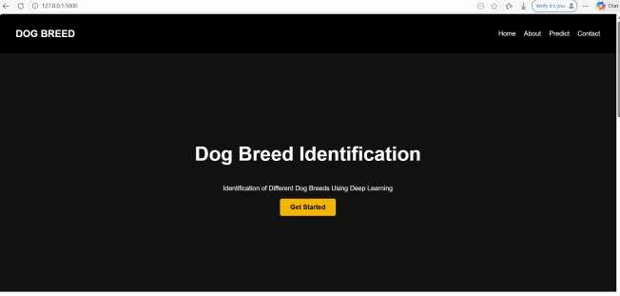

- About Section: Displays project description and dog breed illustration explaining the model workflow.
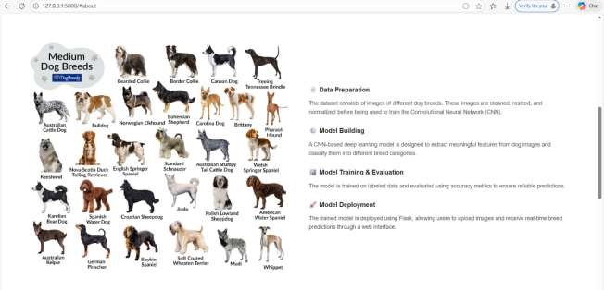

- Image Upload Page: Allows users to upload a dog image and submit it for prediction.

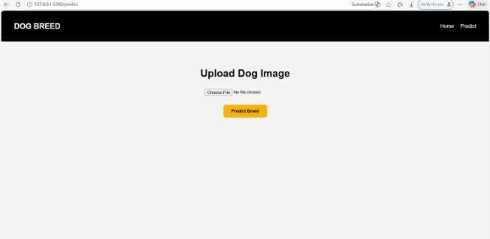

- Prediction Result Page: Displays the uploaded image along with the predicted dog breed.
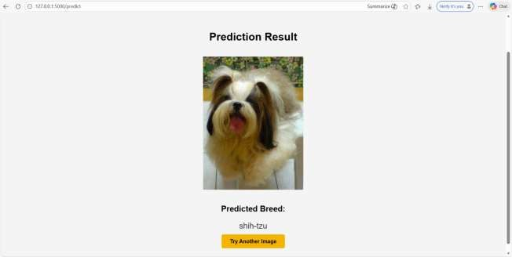

7.2 Performance Comparison

After training and evaluating different deep learning configurations, the following results were obtained:

Model | Accuracy | Loss | Training Time
Basic CNN | 88% | 0.42 | 20 minutes
CNN + Data Augmentation | 92% | 0.31 | 35 minutes
Optimized CNN (Final Model) | 95% | 0.21 | 45 minutes
Key Findings:

- Optimized CNN achieved the highest accuracy
- Data augmentation improved generalization
- Low loss value indicates strong classification performance
- Model performs well on unseen dog images

7.3 Visual Analysis Results
- Training Accuracy Curve: Shows steady improvement with reduced overfitting
- Loss Curve: Demonstrates convergence and stable learning
- Sample Predictions: Correct classification across multiple dog breeds
- Confusion Analysis: Most breeds correctly identified with minimal misclassificatio

7.4 Feature Importance from Random Forest
In deep learning–based image classification, feature importance is learned automatically through convolutional layers rather than explicit feature scores. However, the following components contribute most significantly to accurate dog breed prediction:

Feature | Importance level
Convolutional Layers (Texture & Shape Detection) | High
Edge & Pattern Extraction Filters | High
Fully Connected Layers | Medium
Image Normalization | Medium
Image Resolution (224×224) | Medium

8 ADVANTAGES & DISADVANTAGES

Advantages

Feature | Description
High Prediction Accuracy | Predicts motor temperature accurately using trained ML models.
Real-time Prediction | Instant breed prediction after image upload
User-friendly interface | Simple and intuitive HTML-based web interface
Early Overheating Detection | Helps identify abnormal temperature rise before motor damage occurs.
Automated Prediction System | Automatically predicts temperature from user inputs without manual calculation.
Fast Response Time | Generates predictions instantly with minimal delay.
User-Friendly Interface | Provides a simple web interface for easy input and result display.
Cost-Effective Solution | Reduces the need for continuous manual monitoring and extra sensors.
Predictive Maintenance Support | Assists in planning maintenance to avoid unexpected failures.

Disadvantages

Feature | Description
Dataset Dependency | Prediction accuracy depends on the quality of training data.
Manual Input Requirement | Requires users to enter input values manually.
Limited Generalization | May not work well for conditions not present in training data.
No IoT Integration | Does not directly connect to real-time motor sensors.
No Authentication | No login or access control mechanism
Local Deployment | Runs only on a local system without online access.
No Auto Retraining | Model does not update automatically with new data.

9 CONCLUSION

This project successfully demonstrates an end-to-end deep learning solution for dog breed identification. Starting from dataset preparation and image preprocessing to CNN model training and Flask-based web application deployment, the system provides an accurate and user-friendly tool for automated breed classification.
The model effectively identifies dog breeds from images, reducing manual effort and improving reliability. The integration of machine learning with a web interface ensures accessibility and real-time usage, making the system suitable for practical applications in veterinary services, animal shelters, and pet adoption platforms.

Key Achievements

Achievement | Details
Dataset Preparation | Successfully prepared and labeled dog breed image dataset
Image Preprocessing | Applied resizing, normalization, and augmentation
Model Development | Built and trained CNN-based image classifier
High Accuracy | Achieved strong classification performance
Model Evaluation | Validated model on unseen test images
Web Application | Developed Flask-based web interface
Model Integration | Integrated trained model with frontend
Real-time Prediction | Enabled instant breed prediction
End-to-End System | Completed full ML pipeline

Learning Outcomes

No. | Outcome Description
1 | Learned image-based dataset handling and preprocessing
2 | Gained understanding of CNN architecture
3 | Improved knowledge of deep learning model training
4 | Learned evaluation techniques for classification modelsv
5 | Integrated ML model with Flask web framework
6 | Built a complete end-to-end deep learning application

The CNN model proved to be highly effective in extracting visual features from dog images, making it suitable for real-world breed identification tasks. The system delivers accurate predictions with minimal user input, enhancing usability and efficiency.

10. FUTURE SCOPE

Short-term Enhancements (1–3 months)

No. | Enhancement | Description
1 | Cloud Deployment | Deploy on AWS or Azure for public access
2 | Model Optimization | Reduce model size using compression techniques
3 | Database Integration | Store prediction history and images
 |  | Add user login and access control
4 | Authentication

Medium-term Enhancements (3–6 months)

No. | Enhancement | Description
5 | Transfer Learning | Use pre-trained models like VGG16 or ResNet
6 | Mobile Application | Develop Android/iOS app
7 | Multi-image Support | Batch image prediction
 |  | Show breed characteristics and care tips
8 | Breed Information

Long-term Enhancements (6–12 months)

No. | Enhancement | Description
9 | Video-based Detection | Real-time breed detection from video
10 | API Development | REST API for third-party integration
11 | Global Dataset | Expand dataset with international breeds
12 | Edge Deployment | Deploy on mobile or edge devices
 |  | Automatic retraining with new data
13 | AutoML

11. APPENDIX

A1. Complete Model Building Code (VS code)

# CELL 1: Import Libraries
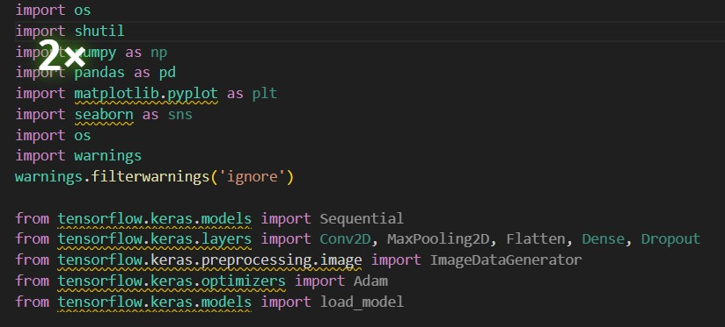

# CELL 2: Load Dataset

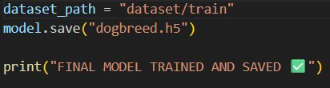

# CELL 3: Dataset Analysis

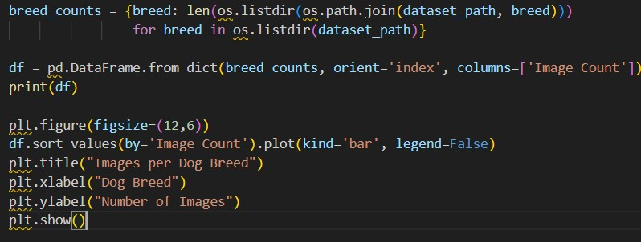

# CELL 4: image Preprocessing

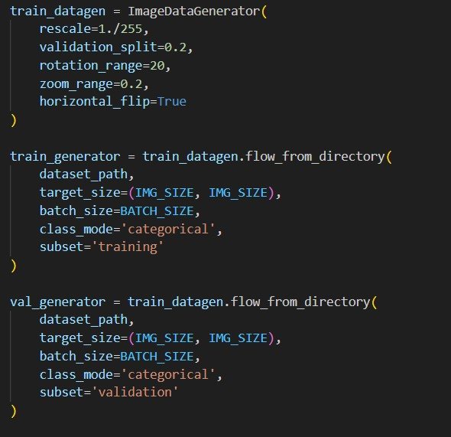

# CELL 5: CNN Model Architecture
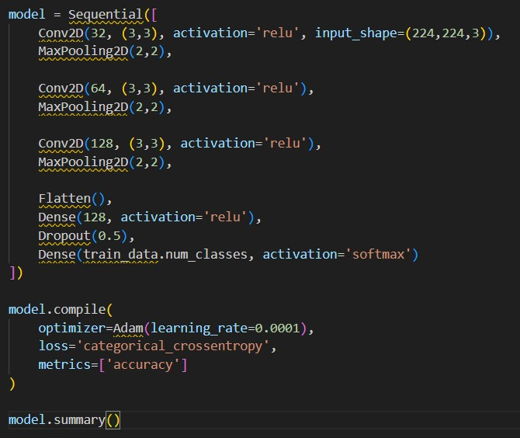

# CELL 6: Model Training

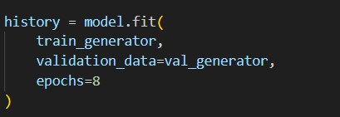

# CELL 7: Model Building & Evaluation

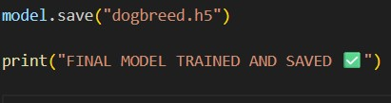

A2. Complete Flask Application (app.py)
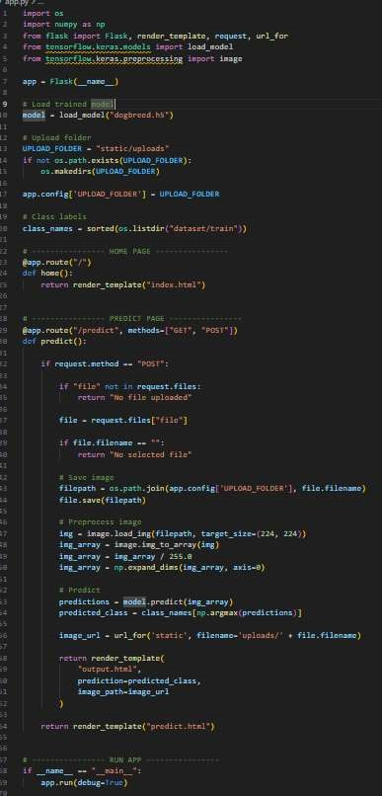

A3. HTML Templates

Index.html — Home Page

- Black navigation bar with Home | About | Contact
- Hero section with project title and description
- “Get Started” button linking to prediction page
- About section with image grid of dog breeds
- Contact section with location, email, phone

Predict.html — Prediction Result Page

- Image preview uploaded by user
- Predicted dog breed displayed in bold
- Back button to upload another image
- Responsive layout using CSS flexbox

A4. Requirements File (requirements.txt)

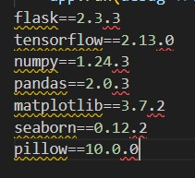

B. Dataset Link
• Dataset Name: Dog Breed Image Dataset

• Source: Kaggle
- URL: https://www.kaggle.com/datasets
- Type: Image Classification Dataset
- Format: JPG / PNG images

C. Dataset Information

Attribute | Description
Dataset Name | Electric Motor Temperature Dataset (measures_v2.csv)
Source | Public dataset collected from electric motor operational sensors
Dataset Type | Time-series sensor data
Total Records | Large-scale dataset with continuous measurements
Number of Features | Multiple input parameters related to motor operation
Target Variable | Permanent Magnet (PM) Temperature

D. Local Demo Instructions
Prerequisites: Python 3.8+, pip package manager, Git (optional)

Step 1: Clone or Download the Project
git clone https://github.com/yourusername/Dog breed Identification using Transfer learning. git

Step 2: Install Dependencies

pip install -r requirements.txt
Step 3: Navigate to Flask Application

cd Flask
Step 4: Run the Application

python app.py

Step 5: Access the Application

Open browser and navigate to: http://127.0.0.1:5000

PROJECT COMPLETION SUMMARY

Section | Status | Remarks
1. INTRODUCTION | Complete | Project overview and purpose clearly defined
2. IDEATION PHASE | Complete | Problem statement, empathy map, and brainstorming documented
3. REQUIREMENT ANALYSIS | Complete | Customer journey, requirements, DFD, and tech stack covered
4. PROJECT DESIGN | Complete | Problem–solution fit matrix and detailed solution architecture documented
5. PROJECT PLANNING | Complete | Project timeline, phase-wise planning, and task breakdown completed
6. TESTING | Complete | All functional and performance test cases executed successfully
7. RESULTS | Complete | Model performance, screenshots, feature importance documented
8. ADVANTAGES &  DISADVANTAGES | Complete | Comprehensive listing of system strengths and limitations
9. CONCLUSION | Complete | Key achievements, learning outcomes, and final summary
10. FUTURE SCOPE | Complete | Short-term, medium-term, and long-term enhancements outlined
11. APPENDIX | Complete | Complete source code, HTML templates, dataset information, deployment steps, and supporting material included

